# NETWORKING & SYSTEM ADMINISTRATION LAB

**Name: Swetha Prakash Roll No: 46**

**Batch: B**

**Date: 04/04/2022**

**Experiment No.: 3**

# Aim

Familiarization of the linux commands.

# Procedure

1. **cp**

This command is used to copy the contents from an existing file to a new file. Syntax :- $ cp existing_filename new_filename

Output :-

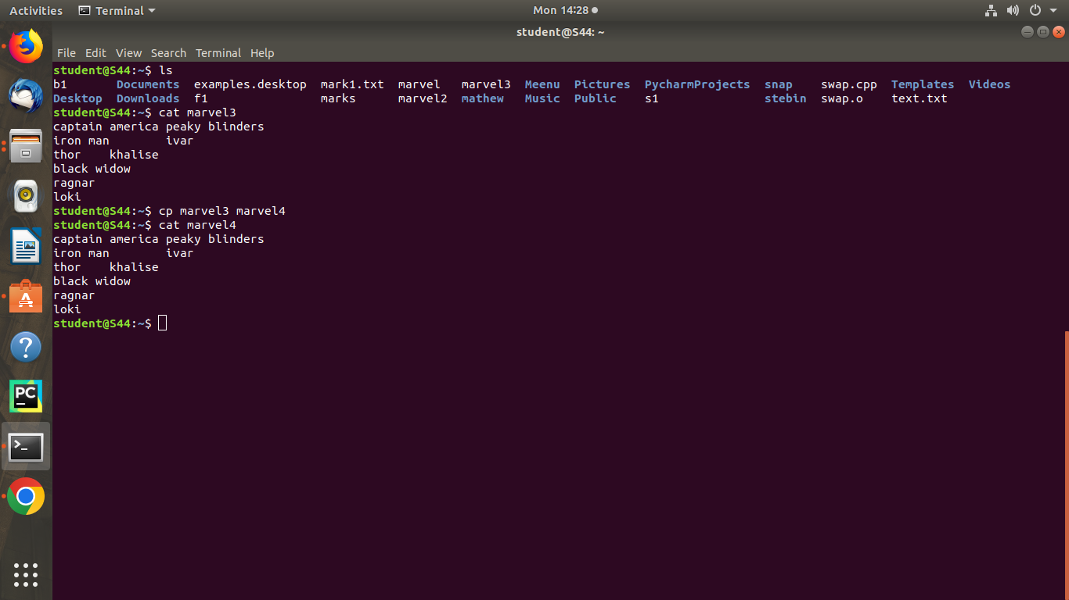

# cp -r

This command is used to copy a directory along with its subdirectories. Syntax :- $ cp -r source_directory destination_directory

Output :-

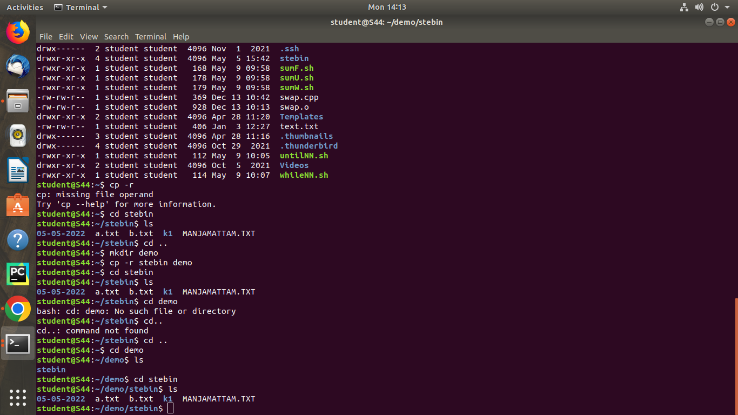

# cp overwriting

This method is used to overwrite the contents of an existing file from one directory to an existing file with the same name in another directory with the cp command.

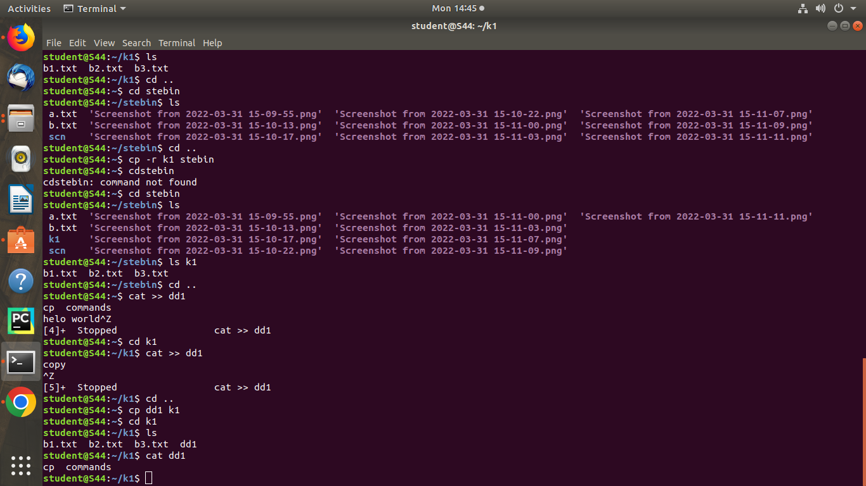Syntax :- $ cp filename directoryname Output :-

# cp -i

This command is used to ask the confirmation message once before overwriting the file. We give ‘y’ or ‘n’ as the response.

Syntax :- $ cp -i filename destination_directory Output :-

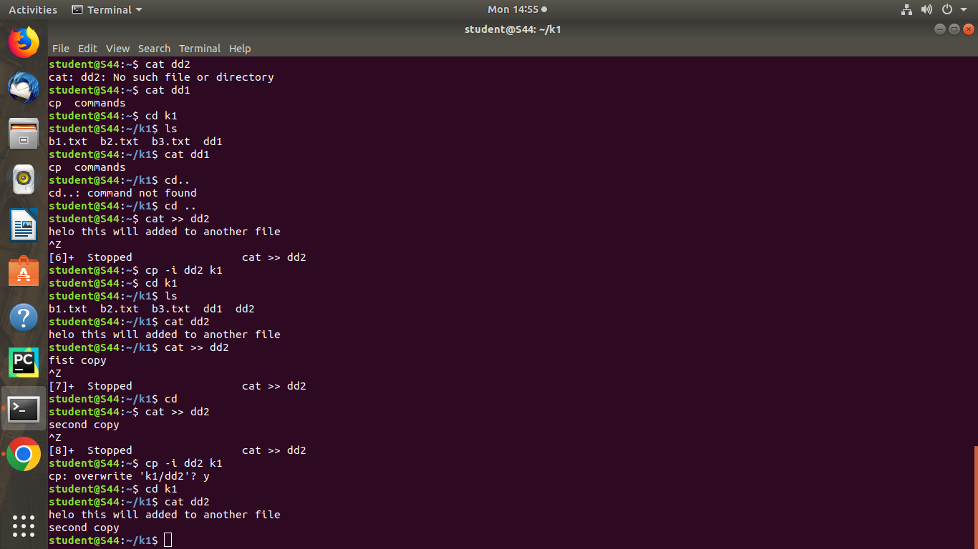

# mv

This command is used to move an existing file or directory from one location to another.

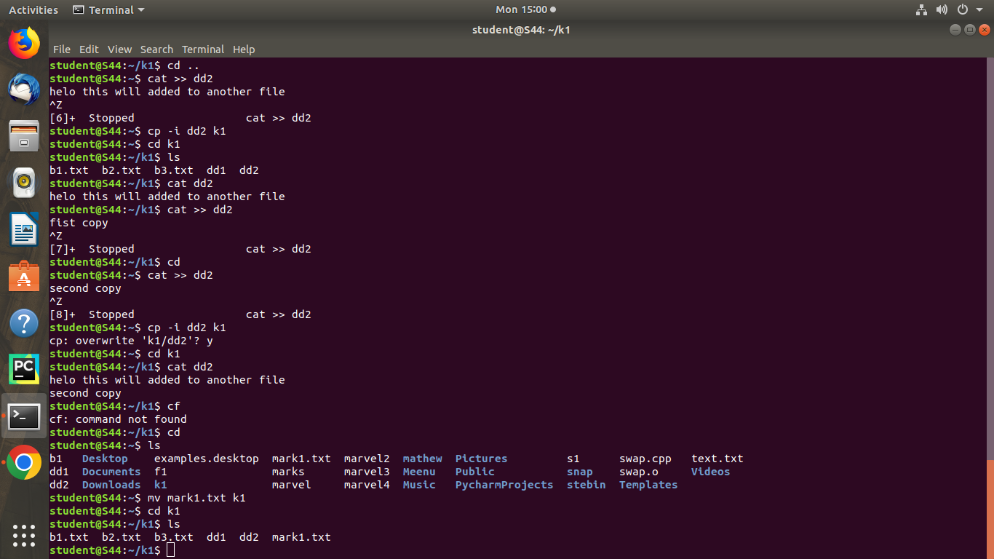Syntax :- $ mv filename directory_name Output:-

# mv overwriting

This method is used to overwrite the contents of an existing file from one directory to an existing file with the same name in another directory with the mv command.

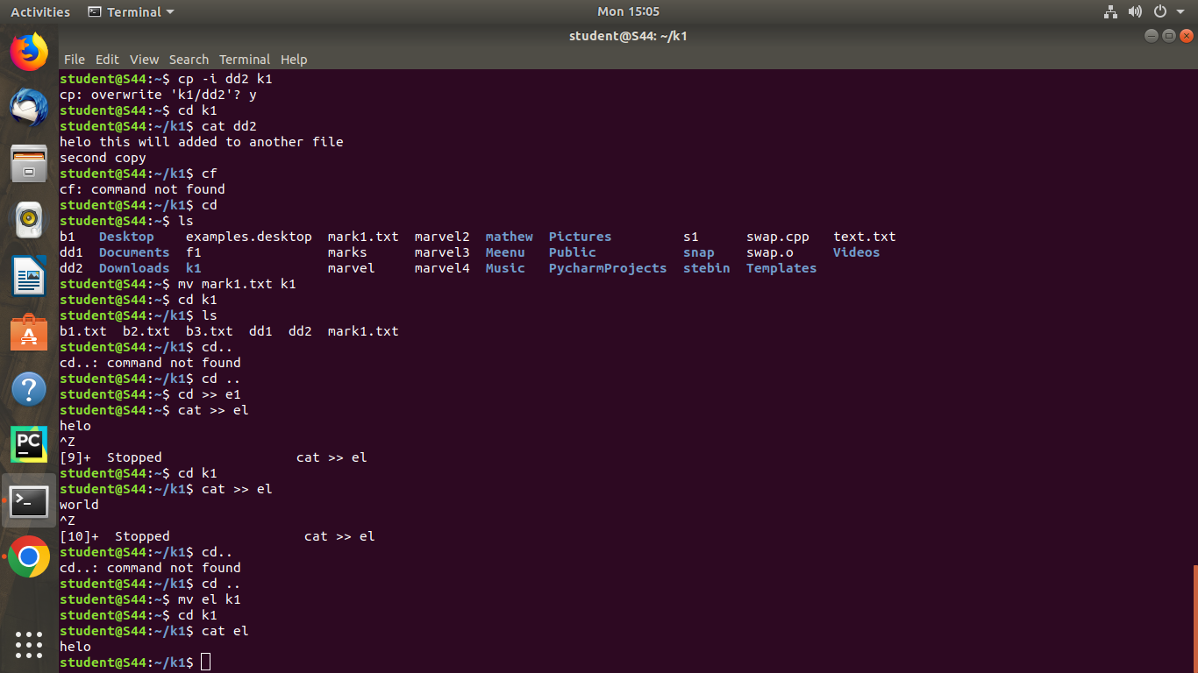Syntax :- $ mv filename directory_name Output :-